Third Grade Supply List
2022-2023
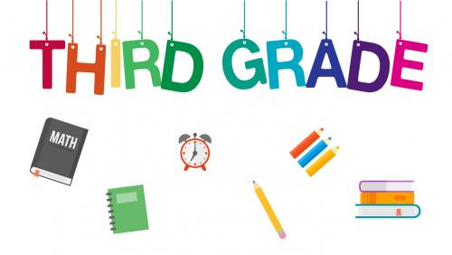
As this school year comes to a close, we would like to wish you a healthy, safe and happy summer vacation. To make it easier in September, we have prepared a list of supplies for the upcoming school year which is divided into two sections – supplies for September and supplies for January. Please try to label your child’s items (first & last name).

SEPTEMBER: Day 1  - 8 notebooks  - 5 folders  - 4 boxes of 12 sharpened pencils  - 1 Scissor  - 3 glue sticks (Elmers preferred)  - 1 Rubber Cement Glue  - Crayons, markers or colored pencils  - 1 pack of loose leaf  - 4 packs of post-its  - 1 pack of any colored pens  - 1 pencil case  - 2 boxes of tissues  - Boys only:  - 1 box of one gallon Ziplock bags  Girls only:  - 1 box quart-size Ziplock bags | SEPTEMBER: Day 2  - 1 pack of dry erase markers with an eraser  - 1 closed pencil sharpener  - 2 black Sharpies  - 2 highlighters  - 2 rolls of scotch tape in the dispenser  (Scotch brand preferred)  - 1 package of Baby Wipes  - 1 roll of paper towels  - 1 package of Band-Aids  - 2 reams of 8 ½ x 11 white duplicate paper 20lb weight  - 1 ream of colored paper (Neon Astrobrights preferred)  - 1 pair of headphones/earbuds  *If your child receives ESL or Speech services, please bring in an extra marble notebook and folder.
JANUARY SUPPLIES: TENTATIVE
Please send these items in January.

- 2 boxes of sharpened pencils
- 1 ream of 8 ½ x 11 white duplicate paper 20lb weight
- 4 packs of post-its
- 3 glue sticks
- 2 boxes of tissues

EVERY DAY
1 healthy snack and drink daily (fruit, vegetable, cheese, yogurt, etc.)

Thank you!
The Third Grade Teachers

