First Grade Supply List
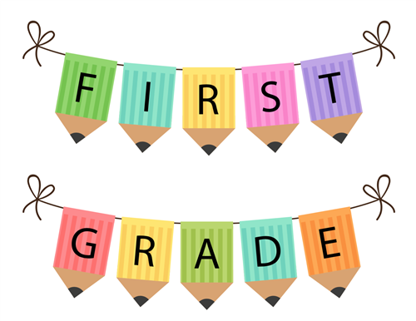
2020-2021

Your child is fast approaching the end of Kindergarten. At this time, the first grade teachers would like to give you an early welcome and introduction to some of your child’s needs in first grade. To make the transition back to school easier, we have a supply list for the beginning of the year (September) and a supply list for the middle of the year (January). Please label all supplies with your child’s name.
SEPTEMBER (Day 1):  Please send these items on the first day of school  - 5 Marble notebooks (wide ruled) labeled with your child’s name and class  - 2 Boxes of sharpened pencils (preferably Ticonderoga) – do not label pencils  - 2 large erasers  - 1 zipper fabric pencil case  - 4 bottom pocket plastic folders (labeled with your child’s name and class)  - 1 green,  - 1 red,  - 1 yellow,  - 1 blue  - 1 small box of Crayola crayons (24) *  - 4 large glue sticks*  - Children’s scissors (plastic handle, metal blade – e.g. Fiskar brand)  - 1 box of tissues* | SEPTEMBER (Day 2):  Please send these items on the second day of school  - 1 container of baby wipes*  - 4 dry erase markers (low odor) and dry erase eraser  - 1 box of one gallon Ziplock bags  - 1 roll of paper towels*  Boys only:  - 1 box of 2.5 gallon jumbo storage Ziplock bags  Girls only:  - 1 box quart-size Ziplock bags
SEPTEMBER (Day 3):  Please send these items on the third day of school  - 1 ream of 8 ½ “ x 11” white duplicating paper (20 lb. Weight)(can buy at Staples, etc.)*  - 2 black sharpie markers (1 ultra fine point Sharpies and 1 Sharpie fine point).  - 1 set of headphones (not earbuds) (in a Ziploc bag labeled with child’s name on the bag and headphones)  Boys only:  - 1 bottle of hand sanitizer  Girls only:  - 1 bottle of soap | JANUARY SUPPLIES:  Please send these items in January  - 1 box of tissues  - 1 container of baby wipes  - 3 packs of post-its (2 packs of 3x3 and one pack of 4x4 with lines)  - 1 package of clear plastic sheet protectors  - 2 black Papermate flair felt tip pens  - 1 Bic 4 color click pen  - 1 roll of scotch tape  - 1 highlighter (any color)  - 1 sturdy clipboard (labeled with child’s name)
* These supplies are often asked to be replenished during the year, you may want to buy multiples of those items when they go on sale.

EVERYDAY
A healthy snack and drink (fruit, vegetable, cheese, yogurt, etc.)

Thank you!
The First Grade Teachers

