Self Contained 3.4.5 - Supply List
2020-2021
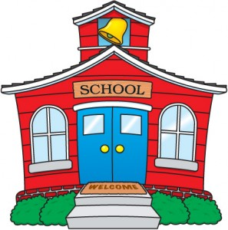
As this school year comes to a close, we would like to wish you a healthy, safe, and happy summer vacation. Below is a supply list for the upcoming school year. For your convenience, the items may be brought in across the first week of school. To make the transition back to school easier, we have a supply list for the beginning of the year (September) and a supply list for the middle of the year (January). Please label all supplies with your child’s name.
SEPTEMBER:

- 2 Avery Heavy Duty 2” Clear Cover Binders (Staples carries them)
  - 1 in black and
  - 1 in white
(if you already have these binders no need to buy new ones)
- 2 packs of dividers (5 tabs) (if you already have dividers no need to buy new ones)
- 1 package 8 1/2 by 11 wide ruled loose leaf paper
- 1 Set of colored Expo dry erase markers and a dry erase board eraser (please don’t get the markers with eraser on top)
- Crayons, colored pencils, and markers
- 2 boxes of tissues,
- 2 rolls of paper towels,
- 1 gallon and 1 quart zip lock bags.
- 1 ream of white multi-purpose copy paper
- 5, 2 pocket folders

Many of these supplies your children already have if they were in my class this year. So please don’t feel that new items need to be bought if they already have them at school. Certain items get consumed and need to be restocked such as tissues, dry erase markers, and paper. Please use your best judgement when purchasing supplies if you are working with a limited budget.
JANUARY SUPPLIES:
Please send these items in January

- Staples brand clear sheet protectors 100 count
- 2 packs of #2 pencils (Ticonderoga please)
- 2 or 3 large erasers (they come in a pack)
- 3 thin/fine point and 3 thick black Sharpie markers
- Colored pens for note taking and editing
- 1 pair of scissors
- 2 large glue sticks
- 1 ruler
- 1 pencil case
- 2 boxes of tissues,
- 2 rolls of paper towels,
- 1 gallon and 1 quart zip lock bags.
- 1 ream of white multi-purpose copy paper
- Colored highlighters
- 1 clip board
- Post its

Everyday
Students may bring in fresh fruit, fresh vegetables, and/or cheese for snack. Water in plastic reusable containers is permitted. Please make sure your child comes to school every day with a book that he/she would enjoy reading during independent reading time.

Thank you!

