Self Contained K.1.2 - Supply List
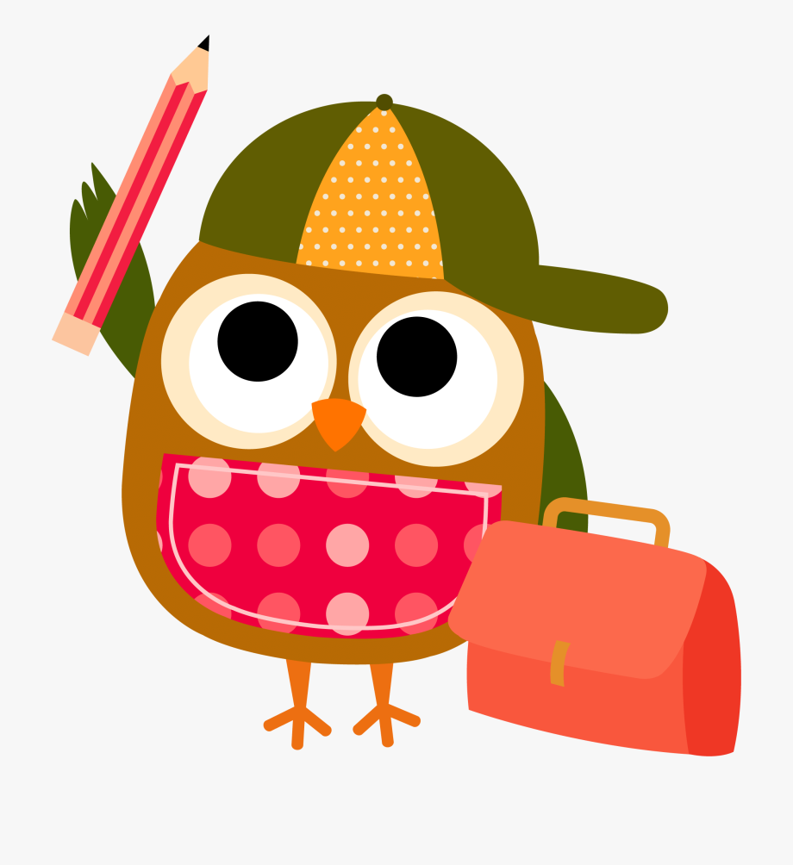
2020-2021

Below is a list of items that your child will need for the school year. While there is a suggested order in which to send the items in, you may send them in in any way that makes it more manageable for you and your child, as there are several items. Please try to provide a backpack that is large enough to fit a large folder and lunch box. In addition, please make sure your child’s backpack and lunch box are clearly labeled with their name and class.

SEPTEMBER (Day 1):  Please send these items on the first day of school  - 4 bottom pocket plastic folders with pockets  - 1 blue,  - 1 red,  - 1 yellow,  - 1 green  - 3 Primary Journal notebooks for grades K-2  - 1 WITH picture box,  - 2 WITHOUT picture box  - 1 pack of sharpened pencils.  - 1 box of Crayola crayons (24)  - 1 supply case ( large enough to hold crayons, pencils, scissors, glue stick).  Please also include an extra set of labeled clothes (shirt, pants, underwear, socks) in a labeled bag. | SEPTEMBER (Day 2):  Please send these items on the second day of school  - 1 ream of computer printing paper (8 1/2 x 11)  - 1 boxes of tissues  - 1 bottle of hand sanitizer  - 1 package of colored pencils  - 2 large glue sticks  SEPTEMBER Day 3:  Please send these items on the third day of school  - 1 pair of children’s scissors  - 1 set of headphones (not earbuds). Please label this item!  - 1 roll of paper towels  - 1 box of quart size Ziplock bags  - 1 box of Crayola Magic Markers
JANUARY SUPPLIES:  Please send these items in January  Day 1:  - 1 box of sandwich size Ziplock bags  - 1 package of dry erase markers  - 1 roll of paper towel  - 1 packages of baby wipes  - 1 bottle of hand sanitizer  Day 2:  - 1 black Sharpie  - 1 package of clear plastic sheet protectors  - 1 package of post-its  - 1 box of tissues  - 1 ream of computer/printing paper (8 ½ x 11) | Every day:  Please send in a healthy snack each day, such as; fruit, pretzels, etc.

Thank you!

